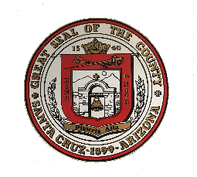
Santa Cruz County News
Media Contact: Shannon Enciso, senciso@santacruzcountyaz.gov
Website: www.santacruzcountyaz.gov
Phone: (520) 375-8285
For Immediate Release
Who: Santa Cruz County Health Department and Mariposa Community Health Center
What: Vaccination program open to all adults, age 18 and over
When: April 5, 2021
Where: Santa Cruz County

Santa Cruz County Health Department in partnership with Mariposa Community Health Center will expand vaccinations to all adults, age 18 and over, who reside or are employed in Santa Cruz County beginning Monday, April 5th. The current pre-registration link will no longer be available after April 1st. Residents who have already pre-registered and have not received an appointment can either make an appointment via our new online system (see below) or call our COVID-19 hotline at (520) 375-7626, Monday through Friday from 8:00 am to 5:00 pm. Residents who do not have access to a computer should call the COVID-19 hotline at (520) 375-7626 to schedule an appointment.

On Friday, April 2nd at noon, county residents and workers will be able to schedule their own appointment, for the week of April 5th, via our new online appointment system. The link for an appointment for the vaccination will be available on the Santa Cruz County and Mariposa Community Health Center websites. Registrants will be required to enter their name, date of birth, phone number, address, and email address. County residents or individuals who work in Santa Cruz County will be required to bring proof of residency or employment to their vaccination appointment. Appointments will become available each week on Friday at noon for the following week. The number of vaccines received each week will determine the number of appointments that will be available.

##End

